Body care

Perfect Body Ultra Firming Body Lotion

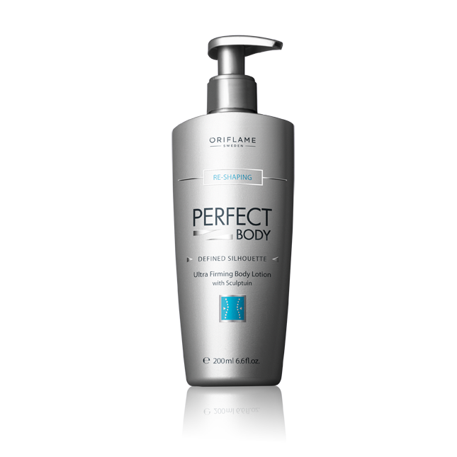
Immediately leaves your body’s skin feeling tauter and more toned, moisturised, and smoother. Contains Sculptuin Complex that strengthens skin elasticity. 200 ml.
Price 19 euro

Perfect Body Firming Bust & Décolleté Gel

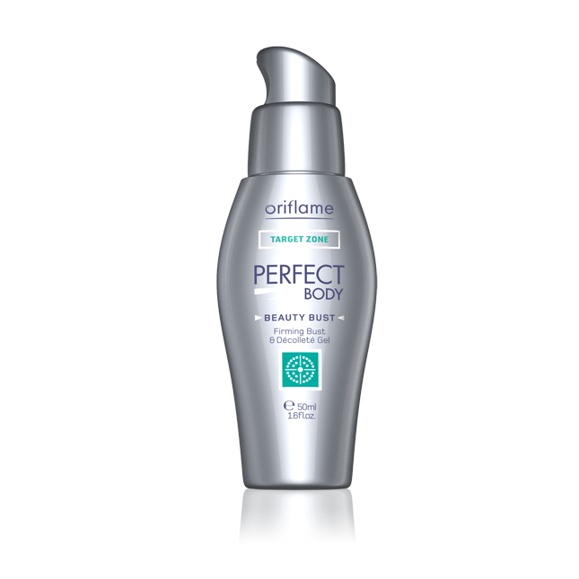
An innovative formulation to firm and lift your bust. Advanced multi-action 3D complex has been proven to firm and tone the skin. Day after day you will be more toned and lifted. 50 ml.
Price 19 euro

Perfect Body Anti-Stretch Mark Cream

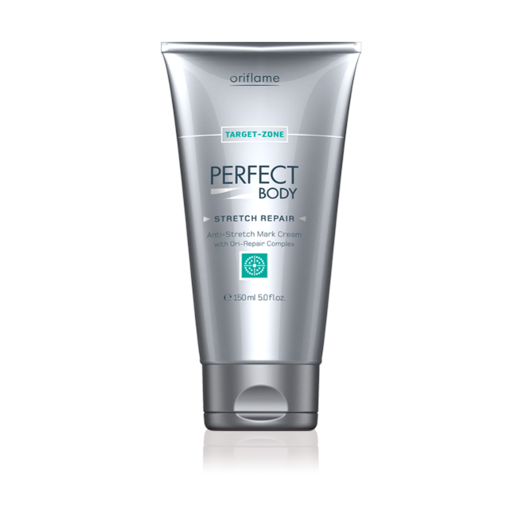
Existing stretch marks are visibly reduced, their size is diminished and their colour faded. Apply the cream every day to areas likely to be affected (stomach, breasts, thighs, hips). Light fast-absorbing texture. Also suitable during pregnancy. 150 ml.
Price 19 euro

Make up

2FX Over Black Mascara

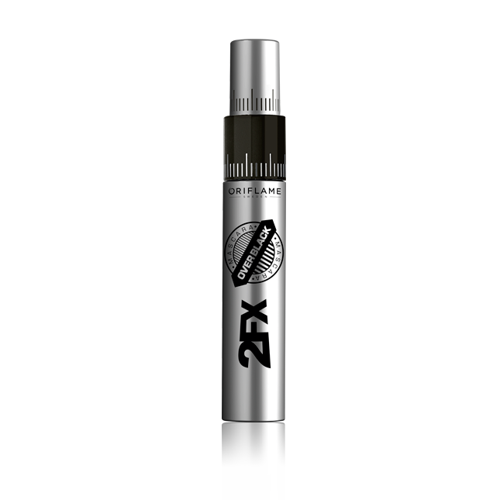
Length or volume? Or both? Whatever your mission, get lashes to match with a 2-in-1 mascara armed with an intelligent brush system that lets you choose from two dramatic lash effects. Limited over-black edition with 3x more pigments. 8 ml.
Price 12 euro

EverLasting Foundation

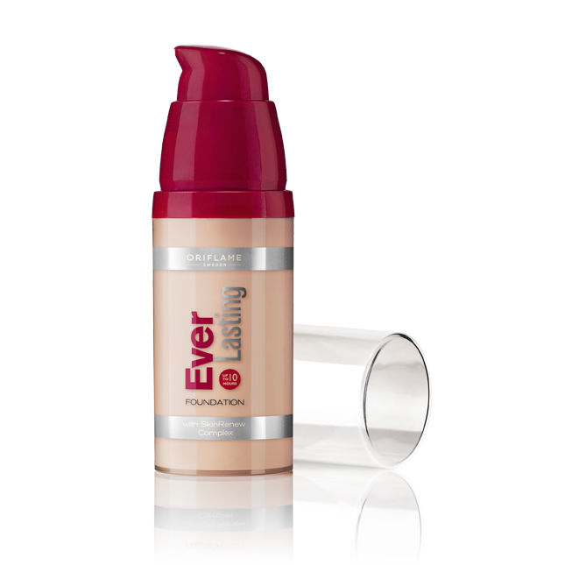
High-performance foundation with Patented Skincare Technology for multi-functional skin benefits. Clinically proven transfer-resistant for long-lasting flawless wear. Lightweight silicone base for velvety-smooth finish and perfect comfort fit. Medium to high coverage. 30 ml.
Price 14 euro

Oriflame Beauty Matte Control Pressed Powder

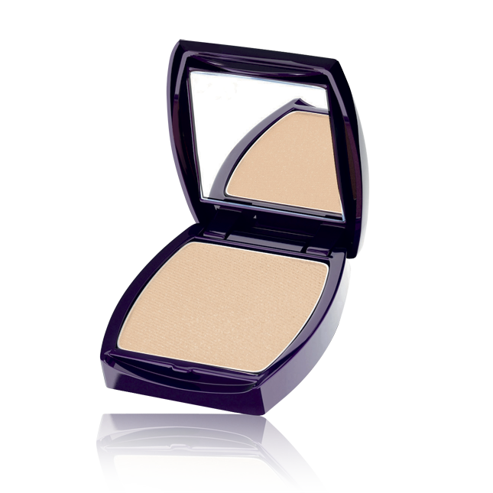
Touch-up using this advanced ultra-fine powder which gives you smooth matte coverage with comfortable wear. Its lightweight formulation contains the mineral zeolite to help mattify the skin. For combination/oily skin. 8 g.
Price 11 euro

Colour Drop Lipstick

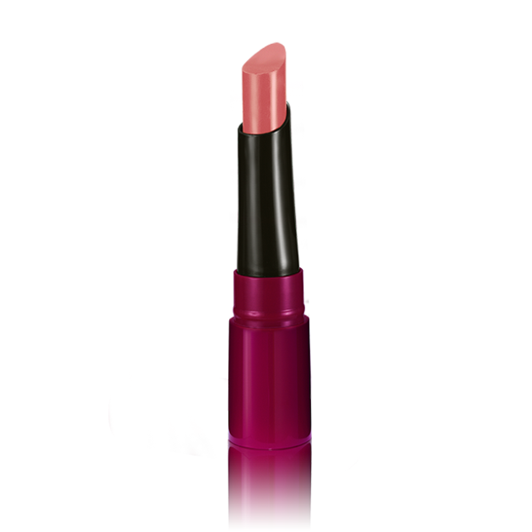
Get endless perfection, intense colour and high shine gloss from the first application to the last drop with the world’s first lipstick to follow the curves of a woman’s lips. With Dew Drop Complex for intense moisture and comfort. 2 g.
Price 11 euro

Fragrance

Eclat Women Eau de Toilette

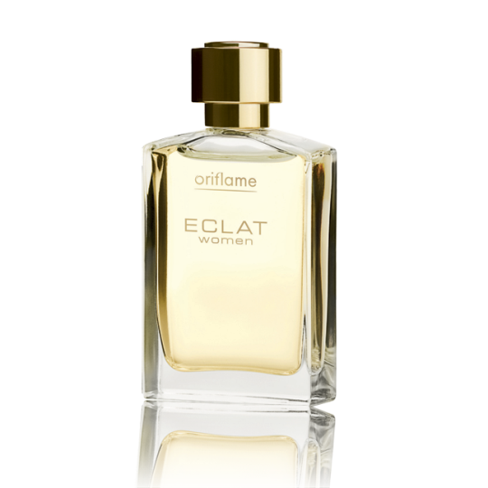
This soft, sophisticated floral fragrance is a subtle expression of understated elegance. Its sparkling fruit notes of Raspberry and Violet are enveloped in its warm, white musk heart. The perfect balance between classic elegance and modernity. 50 ml.
Price 25 euro

Architect Eau de Toilette

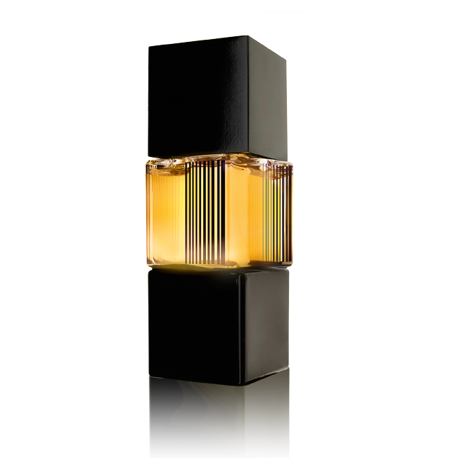
With its invigorating opening of blue hemlock and cardamom, Architect Eau de Toilette opens your world to an astoundingly multifaceted experience. Its dominant, woody framework of gaïac and sequoia later fuses with the spicy tobacco for a scent that captures the organic vision of a contemporary man. 75 ml.
Price 29 euro

Body care

Amber Elixir Body Cream

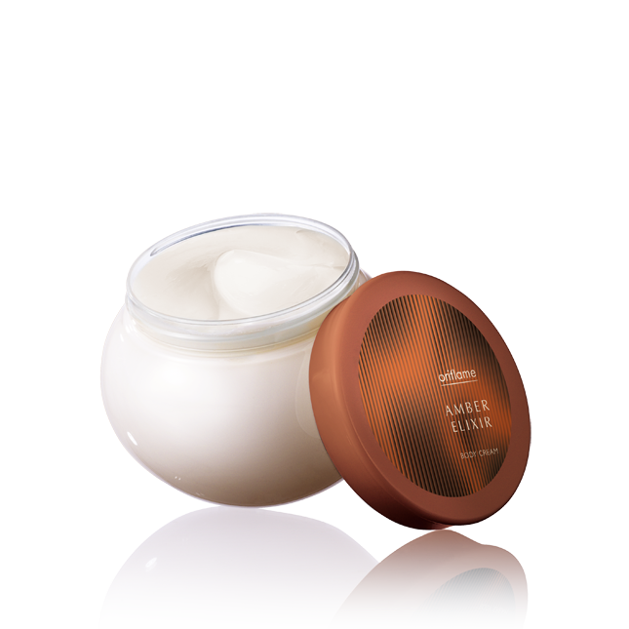
Luscious body cream infused with Amber Elixir’s enticing fragrance nourishes, leaving skin deeply hydrated. Light, non-greasy formula and easy to apply. With long-lasting scent. 250 ml.
Price 10 euro

Cocktails & the City Fashion Addict Body Lotion

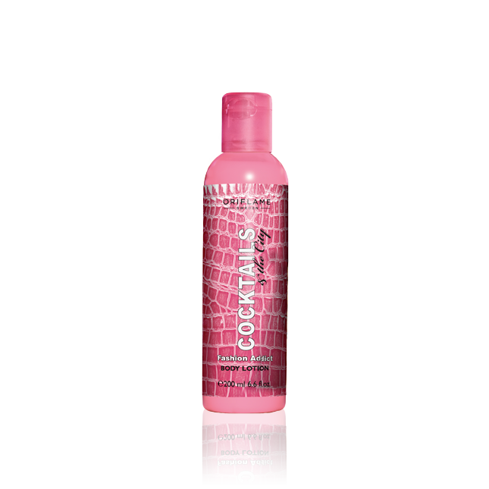
Silky, smooth skin is a must on hot summer nights. Cocktails & the City Fashion Addict Body Lotion entices with fruity, spicy notes of raspberry, cacao and musk. Softens and conditions with nourishing shea butter. 200 ml
Price 2 euro

Aimi Whispering Breeze Shower Gel

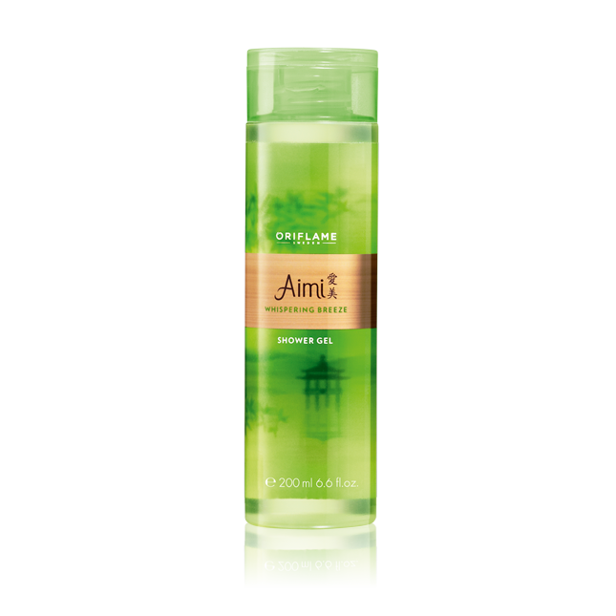
Dream yourself away to the quiet beauty of a bamboo forest this shower gel. Infused with delicate notes of jasmine, wild rose and white woods for a harmonious sensorial experience that gently cleanses skin and leaves it beautifully scented. pH balanced. 200 ml.
Price 4 euro

Delicacy Hand Cream

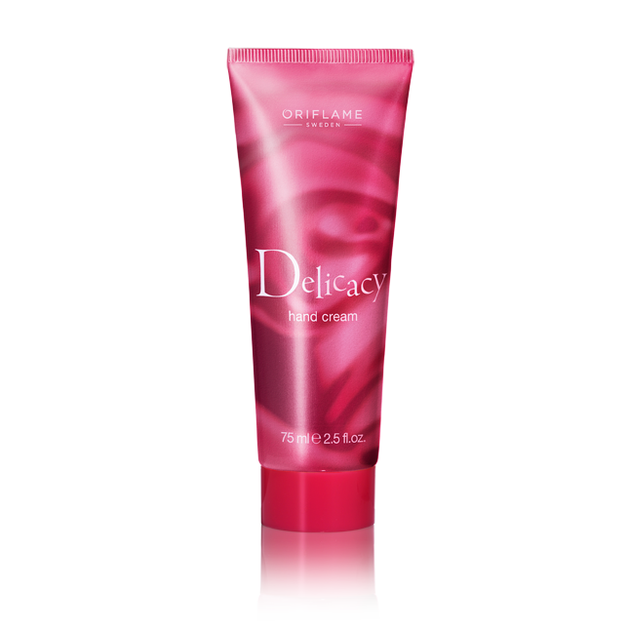
Treat yourself to the lusciously rich Delicacy Hand Cream. Exquisitely refined with the enticing scent of Delicacy, this luxurious cream softens and moisturises your skin. 75 ml. 75 ml
Price 4 euro

Hair care

HairX Daily Care Shampoo

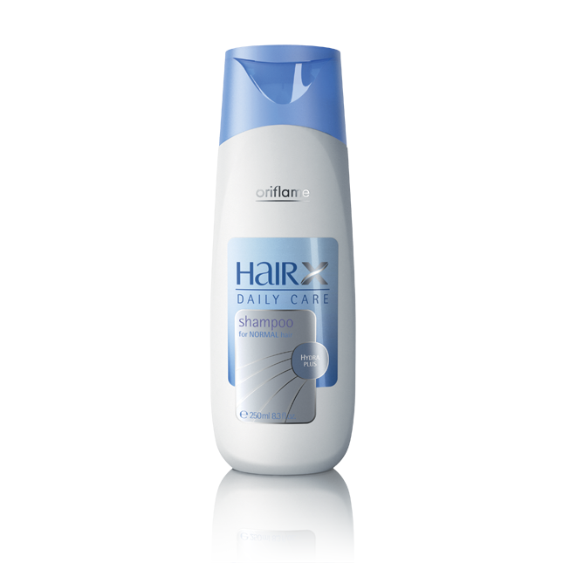
Daily performance shampoo with HydraPlus complex which takes care of the everyday demands of your hair. Clean, manageable, hydrated hair, day in day out. Make it part of your routine, your hair will love it. 250 ml. 250 ml
Price 5 euro

HairX Daily Care Leave-in Conditioner

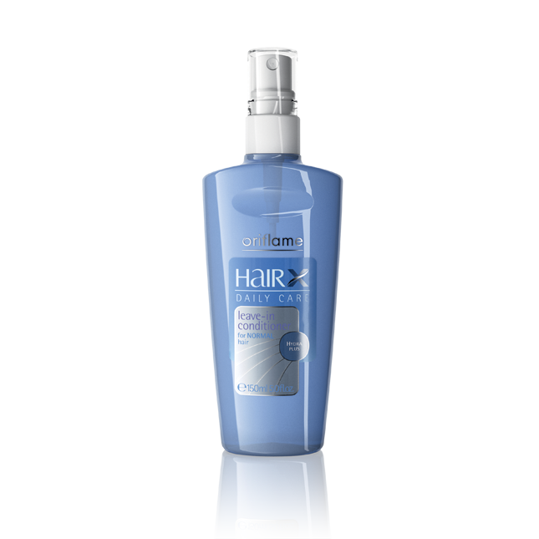
Effective spray with HydraPlus complex that helps to take away tangles and leaves hair hydrated, less frizzy and less flyaway. Spray onto damp, just-washed hair and don’t rinse. Make it part of your daily hair care routine! 150 ml. 150 ml
Price 6 euro

Accessorizes

4-in-1 Face Massager

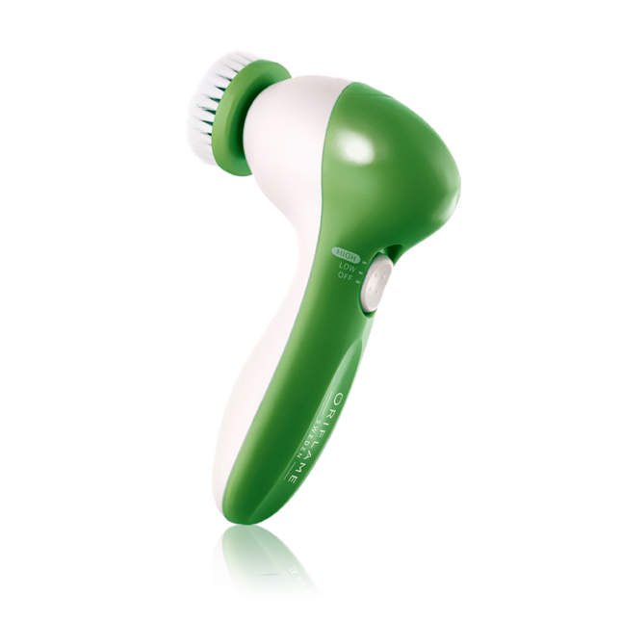
Compact, easy-to-use massager that helps improve circulation, promoting healthier-looking skin. With 4 removable applicators. Takes 2 x AA batteries (not included). Green. White. ABS. Nylon. Latex. 0 *
Price 18 euro

